# MINOR-1 PROJECT

**SYNOPSIS REPORT**

## For

**COMPUTER BASED SIMULATION OF RAIL NETWORK TO REALIZE SHORTEST PATH ALGORITHM**

Submitted By

|  |  |  |  |
| --- | --- | --- | --- |
| **NAME** | **SAP ID** | **ROLL NO** | **SPECILIZATION & BATCH** |
| ROHAN BAKSHI | 500096302 | R2142211066 | BTECH CSE CCVT B-6 |
| VILISH KUMAR | 500095673 | R2142211034 | BTECH CSE CCVT B-6 |
| ASHISH KUKRETI | 500096132 | R2142211009 | BTECH CSE CCVT B-6 |
| VINAMRA SHAHI | 500095831 | R2142210992 | BTECH CSE CCVT B-6 |



## Department of Systemics School Of Computer Science

UNIVERSITY OF PETROLEUM & ENERGY STUDIES,

## DEHRADUN- 248007. Uttarakhand

Mr. Alok Jhalidiyal Dr. Hitesh Kumar

**Project Guide Cluster Head**

# Table of Contents

|  |  |  |
| --- | --- | --- |
| **S.No.** | **Title** | **Page No.** |
| 1 | Abstract | 3 |
| 2 | Introduction | 4 |
| 3 | Literature Review | 4 |
| 4 | Problem Statement | 4 |
| 5 | Objectives | 4 |
| 6 | Methodology | 5 |
| 7 | Algorithm | 5-6 |
| 8 | SWOT Analysis | 6-7 |
| 9 | PERT chart | 8 |



#### School of Computer Science

University of Petroleum & Energy Studies, Dehradun

**Synopsis Report**

**Project Title**

Computer Based Simulation Of Rail Network To Realize shortest Path Algorithm

### Abstract

The increasing complexity of modern rail networks demands efficient route planning systems to enhance transportation logistics and passenger experience. This project focuses on developing a computer-based simulation that models a rail network, with railway stations as nodes and the distances between stations as edges. The primary objective is to implement Dijkstra's algorithm to determine the shortest path between two railway stations.

The simulation begins by representing the rail network as a graph, where each node corresponds to a railway station and the edges represent the distances between stations. Real-world data, such as track lengths or travel times, can be utilized to accurately reflect the rail network's characteristics. The Dijkstra's algorithm is then applied to find the shortest path from a source station to a destination station, considering the cumulative distances along the railway edges.

Three Categories of it’s are:

1. **Passenger Travel and Commuting:** It helps in enhancing the efficiency of public transportation systems, reducing travel times, and improving the overall experience for passengers.
2. **Freight Logistics and Transportation:** This is crucial for minimizing transportation costs, ensuring timely deliveries, and optimizing the use of freight rail networks, supply chain by identifying the shortest and most cost-effective paths for transporting goods between production facilities, distribution centers, and markets.
3. **Railway Operations and Planning:** It helps in minimizing travel time, reducing congestion, and improving overall efficiency in the movement of trains.

Problems in managing are:

1. **Dynamic Network Changes:** Managing real-time updates and adjustments in the simulation to account for dynamic changes in the rail network, such as maintenance or unexpected closures.
2. **Data Accuracy and Reliability:** Ensuring the precision and dependability of simulation outcomes by regularly validating and updating input data to reflect the current state of the rail network.
3. **Scalability and Computational Efficiency:** Optimizing the simulation's ability to handle larger and more complex rail networks by improving computational efficiency and scalability.

### Introduction

Computer-based simulation, employing a graph-based model of the rail network, where nodes signify railway stations and edges denote the distances between stations. Utilizing real-world data, such as track lengths and travel times, the simulation leverages the attributes of the actual rail network. The focal point of this endeavor is the implementation of Dijkstra's algorithm, aimed at determining the shortest path between any two railway stations. This simulation not only represents the rail network's topology but also calculates optimal routes by considering cumulative distances along railway edges, contributing to the advancement of efficient and effective rail transportation systems.

### Literature Review

Computers can simulate rail networks, researchers highlight the importance of using graph-based models to accurately depict the details of railways. These models use nodes to represent stations and edges to show distances between them. Scholars are keen on using real-world data, like track lengths and travel times, to make simulations more realistic and reflective of actual rail systems. A main focus in this research is on Dijkstra's algorithm, a powerful tool for finding the best paths between stations in simulations. By combining this algorithm with real-world data, researchers aim to make rail transportation systems more efficient. Real-life examples, like [specific examples or case studies], illustrate how these simulations can optimize routes and improve overall network efficiency. Overall, the literature emphasizes the importance of using computer-based simulations, especially those incorporating Dijkstra's algorithm, to enhance and shape modern rail transportation networks.

### Problem Statement

Rail transportation currently struggles with inefficient route planning and suboptimal resource use due to the limitations of traditional methods. The proposed solution involves a computer-based simulation using Dijkstra's Algorithm for optimal route planning, aiming to overcome these challenges. However, developing and implementing this simulation present their own complexities, necessitating a well-defined problem statement.

### Objectives

* + Computer based simulation of rail network in which (Railway Stations are my Node and distance is edge)
  + Implementation of algorithms to find shortest path.
  + Comparison of implemented algorithms

### Methodology

### ALGORITHM

### 8.1 AREA OF ALGORITHM

**Retail Stores:** Retail businesses can use this system to manage their product inventory, add new products, update prices, and track product quantities. It helps in maintaining accurate stock levels and prevents overstocking or understocking.

**Warehouses:** Warehouses can benefit from this system to keep track of the items stored, their quantities, and their locations within the warehouse. It aids in efficient storage and retrieval of products.

**E-commerce Businesses:** Online retailers can use this system to manage their product listings, update prices and descriptions, and monitor inventory levels for the products they sell online.

**Small Businesses:** Small businesses, including local shops and boutiques, can use this system to manage their inventory without the need for complex and expensive software solutions.

**Educational Institutions:** Schools, colleges, and universities can use a simplified version of this system to manage their equipment and supplies, such as textbooks, computers, and laboratory equipment.

**Manufacturing Companies:** Manufacturers can use this system to keep track of raw materials, work-in-progress (WIP) items, and finished goods within their production facilities.

**Restaurants and Cafes:** Restaurants and cafes can manage their food and beverage inventory using this system, helping them control costs and reduce food wastage.

In summary, the application area of this Inventory Management System is broad and can be used by various businesses and organizations to streamline their inventory-related processes, improve accuracy, and make informed decisions about inventory management. The system can be customized and extended to meet the specific needs of different industries and businesses.

### SWOT Analysis

A SWOT analysis is a strategic planning tool used to assess the strengths, weaknesses, opportunities, and threats associated with a project, business, or situation.

#### Strengths:

**Functionality:** The code provides basic functionality for managing an inventory system, including adding, removing, updating, and viewing products.

**Modular Design:** The code uses classes to organize data and functions, promoting modularity and code reusability.

**File I/O:** It supports saving and loading inventory data from a CSV file, which can be helpful for data persistence.

**User-Friendly Interface:** The program offers a simple text-based user interface that is easy to understand and navigate.

**Error Handling:** It includes basic error handling, such as checking for duplicate product IDs and file open failures.

#### Weaknesses:

**Limited Error Handling:** While the code does some error checking, it lacks robust error handling for various edge cases, such as invalid input types.

**No Data Validation:** There is no data validation to ensure that user inputs are within reasonable bounds (e.g., negative prices or quantities).

**File Handling Limitations:** The file handling code could be improved for better error handling and more flexible file paths.

**Console-Based:** The user interface is console-based, which may not be user-friendly for non-technical users.

#### Opportunities:

**Enhanced User Interface**: Consider developing a graphical user interface (GUI) to make the system more user-friendly and visually appealing.

**Advanced Features:** You can expand the system by adding features like data analytics, reporting, or barcode scanning.

**Database Integration:** Consider integrating a database for better data management and scalability.

**Security:** Implement user authentication and access control to protect sensitive inventory data.

#### Threats:

**Competition:** If there are competing inventory management systems with more features and better user interfaces, your system may face challenges in gaining market acceptance.

**Technological Changes:** Rapid advancements in technology may require constant updates and maintenance of the system to remain compatible and secure.

**Data Security:** With the storage of sensitive inventory data, there's a potential threat of data breaches if security measures are not adequately implemented.

**Regulatory Changes:** Changes in regulations related to inventory management or data privacy can impact how the system operates.

### PERT Chart

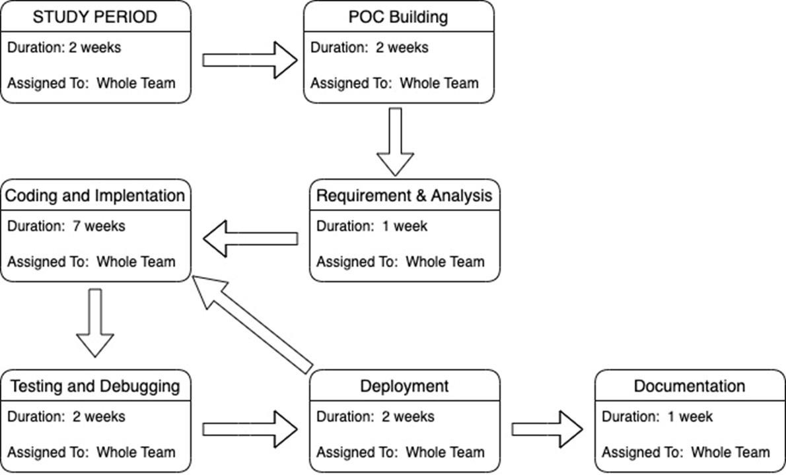

1. **GitHub Link**

[**https://github.com/AshishKukreti2003/ INVENTOWARE**](https://github.com/AshishKukreti2003/__INVENTOWARE__)